Muscle Tone: Walking is a Core Event
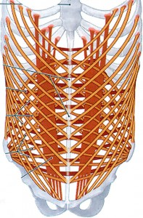
Walking is a core event that requires a good deal of muscle tone. The core refers to three main muscle groups: The inner thighs, the pelvic floor and the abdominals. The psoas (our favorite muscle) is the main engine of walking and when it is properly toned and aligned it allows the body to move with the most efficiency and ease. Without balance and muscle tone in our core the psoas won’t be free to function at its best.
The inner thighs, known as the adductors (there are five of them), tend to be weaker than the outer thighs and in almost all cases need to be awakened to their proper role in walking. The inner upper thigh needs to move backwards with each step to help the psoas do its thing. Instead, most often, the inner upper thighs externally rotate diminishing so much core potential in our walk.
The pelvic floor, muscularly known as the levator ani (three muscles), is called upon to serve a different role in modern man than in our predecessors. Our shift from quadruped to biped has not been an easy one. If you think about four-legged animals, the pelvis is the back wall of the body so the abdominal wall supports the internal organs. As a result of standing upright, our pelvic floor has become responsible for holding up our organs. This shift in responsibility is well deserved of our attention if we hope to walk well as well as age well.
The belly is made up of four abdominal muscles all of which need balanced muscle tone to function properly as they are essentially connected through assorted structures of the inner body. The average person will have much more tone in one or another of these muscles for different reasons. Classically we are way too developed in the most surface of these muscles, the rectus abdominus – otherwise known as the six-pack.
Proper muscle tone and balanced function in these groups allows for the correct alignment of the legs, pelvis and lumbar spine, which creates the best environment for housing the internal organs and freeing the psoas to work at its best. Walking becomes a core event when balanced muscle tone allows the body to work as it should.

