Your Position in Life
Good question in my Ask Katy today:
“Standing work stations are clearly a good idea and I have fashioned one for myself. But what is too much standing? We all know that people whose jobs require constant standing like restaurant servers and factory workers are often plagued with varicose veins. Is there a balance to be struck here?”
This is a great question.
So, we’ve got a situation where sitting constantly is creating disease and standing constantly is creating disease. Do you see the theme? Although the research and media are going to probably miss the boat on this one, the problem isn’t the sitting (or the standing, for that matter), but the constant and continuous use of a single position. Even this question smacks of someone from a North American and European perspective. As if sitting is bad and standing is bad, the only option left must be lying down. As if there is only three choices to how you position your body. As if there isn’t about a thousand different ways you could position your body.
Believe it or not, the positions you are able to get your body in were learned via observation. Our culture’s use of chairs and toilets, our beliefs in what our posture means to others (think of women who cross their legs and adjust their heads to demure or men who jut their chests and flex their elbows to communicate authority), and even our clothing (rigid shoes, narrow skirts for women, etc.) have all resulted in self-induced joint-rigidity. All the movements you have never done are movements that would have toned muscle, keeps connective tissues moist and supple, and blood oxygen flowing evenly, to all areas of the body. Instead, we have huge chunks of unused muscles, bones scraping together at the joints and increasing friction (causing osteoarthritis) and we are constantly medicating to make living possible in our physical agony. This all sounds pretty depressing, I know, but the totally awesome, super-cool and exciting thing is it can be different whenever you’re ready.
Another awesome thing is, while I may seem like the only person saying this strange things, there are actually other people out there who have researched this for the last one hundred years. The big difference between then and now was 1) there wasn’t the internet, which must have made it very difficult to share insights collectively, and 2) there is a wide breadth of subjects a “good education” covers. Most of the people observing the very real phenomenon of cultural postural habits and habitual uses of the body (physical anthropologists) and the people in charge of health education and prescription (medical community) are two completely different sciences. They don’t even talk to each other, even at parties. But, I am hopeful my education in Biomechanics of Human Movement and Disease coupled with my awesome typing skills and Al Gore’s internet is going to help. How is this information ever going to get to you, the people? One blog at a time, I guess.
One extremely cool journal article from 1955 reported the findings of physical anthropology professor Gordon W. Hewes, World Distribution of Certain Postural Habits. It is an amazing read, and if you’d like to have more than my take on it, you can get it here: http://www.jstor.org/pss/666393
As many anthropologists know, the way we move is mostly a result of our cultural inheritances and has very little to go with genetics. Clothing, terrain, temperature, gender, class, and fear are only a few of the many factors that affect how we adjust our joints when sitting and standing. Hewes reported on about 100 resting postures of the world, and I have posted this image from the study so you can see, perhaps, why our Western joint health and metabolism (which is dependent on muscle length) is the poorest in the world.
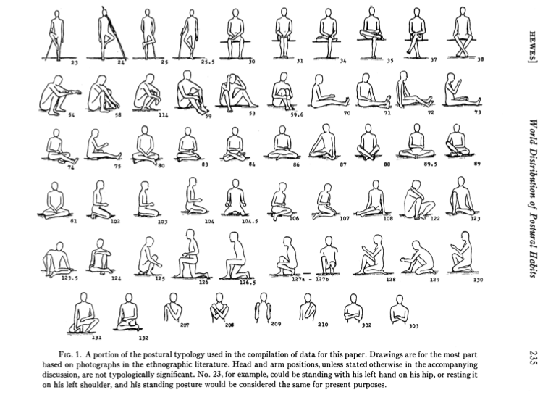
So, we need to think bigger. There is more than just sitting and standing. Create ten different options of each! If you have a standing work station, stand a few different ways every hour. When you sit, sit a few different ways every hour. Open your mind and open your joints! When you get home, stay out of your chairs and try out a lot of these Worldly Options. (Note: If you don’t have a spear, a broom may work…) Circle the ones you can’t maintain for longer than five minutes and make a note to practice that posture at the beginning and the end of an exercise session. And, parents, don’t insist that kids sit in the same fashion as us stiffer folks and allow them to explore other options. And, join them! They can teach you something about natural movement.
Also, if you do spend a yoga/stretching class cycling through10 or so of these postures, know that while this cycle is a good thing, getting back into the sitting position the other 6-10 hours of the day reduces your health just the same. Adjust the way you sit, as often as possible for a real, deep, and cellular change.
Hewes concludes his research:
Physiologists, anatomists, and orthopedists, to say nothing of specialists in physical education, have dealt exhaustively with a few “ideal” postures-principally the fairly rigid attention stance beloved of the drillmaster, and student’s or stenographer’s habits of sitting at desks. The English postural vocabulary is mediocre-a fact which in itself inhibits our thinking about posture. Quite the opposite is true of the languages of India, where the yoga system has developed an elaborate postural terminology and rationale, perhaps the world’s richest. In conclusion I should like to stress the deficiencies in our scientific concern with postural behavior, many of which arise simply from the all too common neglect (by nonanthropologists) of cross-cultural data.
I concur.

