Alignment Matters | Issue No. 2: Alignment. Nutrition (and Spinal Degeneration)

YOU'RE NOT STARVING,
BUT YOUR TISSUES MIGHT BE
by Katy Bowman, M.S.

I love to eat, and I hope that you do too. Nutritional requirements are a biological imperative, meaning, without the intake of nutrients, we die. Everyone knows that, right? What you might not have known is, the same nutritional intake is required on a cellular level. Your cells need to be "fed" in order to keep going, and without cellular food, tissues die.

Which brings me to a little thing called degenerative disc disease. Have you heard of it? Back pain is a huge world-wide problem and chances are, by the time your back pain has progressed to the level of medical treatment, you will see this term somewhere on your chart:
Degenerative Disc Disease (DDD). What is it? If I didn't know much about anatomy or physiology, it seems like I might have something, some bacteria or fungus that is eating away at my disks until the bones of my vertebrae are rubbing together placing my spinal cord in peril. Maybe my disks are just old and are starting to break down.
Well, it turns out that DDD is just the result of years of extreme dieting - on the cellular level, that is. DDD is often linked to age, but more correctly, should be linked to years spent in a particular posture that has decreased the amount of nutrients to the area.
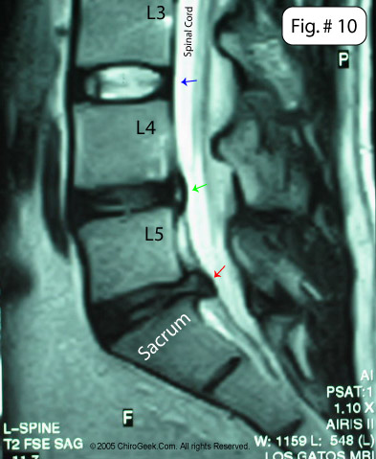

A little trivia Q: What do spinal discs eat?
A: Oxygen and glucose.
How to feed your discs
The flow of your blood delivers nutrition everywhere in the body, and the intervertebral discs are no exception. What is most pertinent to back health is how nutrition reaches tissues. When we think of blood moving, we picture the heart, pumping away, but it is really the action of skeletal muscle - contracting and relaxing - that creates the flow of nutrients.

The spinal discs between the vertebrae are essentially like little sponges - squeezing out waste (lactate or lactic acid) and creating a vacuum-like suck when released. Each vertebra has a set of muscles that connect it to the next bone above and below. It is imperative to the health of the disk that your spine be able to articulate at each point.
Alignment and spinal health
Your habitual posture is a particular set of joint positions that you have made your default. And like most defaults, it is easy to return to this posture over and over again, until the muscles have stiffened, creating a fusion-like situation. Our modern daily living does not require us to move in unique and novel ways. Over time, the muscles, in their stiff position, fail to assist in nutrient delivery, resulting in cellular death and eventual disc collapse. This is what we call degenerative disk disease.
Bummer, right? Well, the good news is, you can start the process of nutrition delivery simply by stretching. This creates a pull and then a release of tissues that begin the gentle massage that creates nutritional flow. And **bonus**, it also aids in waste removal from the deepest part of the spinal disc.
This is great news! For many years, researchers believed that movement had nothing to do with spinal disc health. Now they know better, as better designed research has shown that mechanical loading of the spine is what maximizes nutritional flow!
Some guidelines:
For best back health, it's not just the spinal muscles that need to be stretched but any that affect the position of the spine. This includes calves, hamstrings, groin, and psoas muscles.
Stretches or positions that are easy for you are probably not very beneficial. It is much more important to stretch the muscles that are difficult to get to.
When stretching your spine, move slowly and be gentle with yourself! Also, pay attention to stretching guidelines. The reason I spend so much time giving parameters of safety is to increase the effectiveness of the stretch while keeping you safe and sound!

Read the research or additional coverage at BBC.com.

